

CENTENNIAL COLLEGE PROGRESS CAMPUS

COURSE COMP229 Winter 2017 – Midterm Exam

**Implementation**

This is the how we should define our Default page:

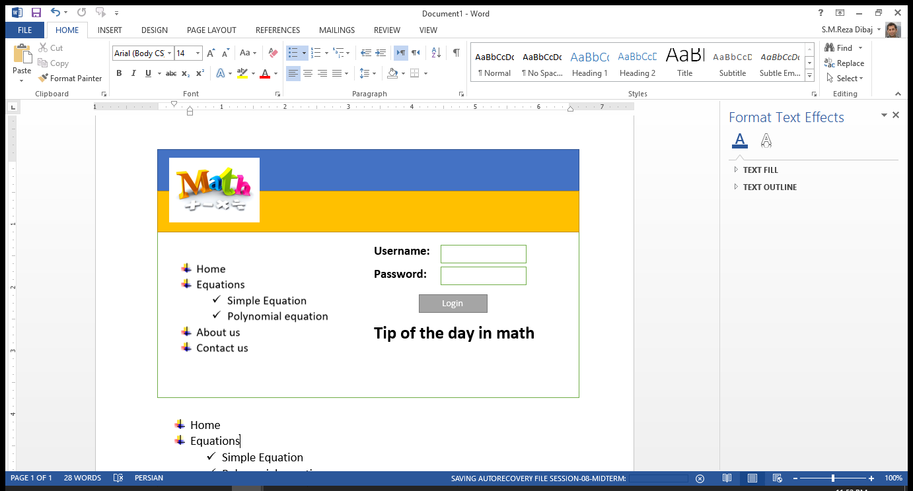

**Implementation steps:**

1. Provide a Site Map that contains the above site structure.
   1. add two subdirectory to Equations:
      1. Simple Equation
      2. Polynomial equation
2. Create separate aspx file for each item in the above menu
3. In Polynomial equation webpage, please provide three textboxes to receive a, b and c from the user and calculate X1 and X2.

**Hint:** You have to define a function to calculate the following equation. You can use similar approach that you had for factorial calculation.





1. Create a **App_Themes** folder in the **Solution Explorer** and add **MathTheme** as a New Item there.
2. Create a style sheet there and name it **MyMath** and define an appropriate style in it.
3. Define a skin for your Server Control textboxes as the font, forecolor and back color are defined differently from the default.
4. **IMPORTANT:** Explain how to connect your skin and your text boxes together.
5. Explain what is the main difference between CSS and Skin?
6. Define a master page that contains header, menu and a content section. Define an appropriate image for the header and the menu items.
7. Explain how to hide the root in the menu

**NOTE:**

**Define each step of the above sections separately in your MS Word Document.**

**Questions**

**Question 1:**

a) What is ViewState? b) Where the viewstate is stored after the page postback? c) How long the items in ViewState exists?

**Question 2:**

What is the role of Directives in ASP.NET code? What did you use them for? What were problems that you faced when you wanted to use Directives? What was your solution for them?

**Question 3:**

When do we use server-side comments and when do we use the client side comments?

What can happen if we misuse them and what could we receive as potential error? What is your solution for it?

**Question 4:**

Why in some languages we need to define variables at the beginning of the code and why we do not need to do so in some others? When should we use global variables and when should be use local ones? Why? Which one do you pick as your default?

**Question 5:**

Briefly define the following concepts in Object Oriented Programming:

objects:

properties:

methods:

classes:

scope:

events:

inheritance:

**Question 6:**

Which one do you prefer to use, a code-behind or <scrip>? What are the pros and cons of each of them?

**Question 7:**

Suppose you want to link to a webpage using one of the following controls. Which one are you going to use and why? Which one did you have difficulty when you wanted to use?

* Button
* ImageButton
* LinkButton
* HyperLink

**Question 8:**

Explain about application state, session state and cache object. Explain the cases that we should use any of these types. What can we use instead of cache object between application state and session state?

**Short Questions**

**Short Question 1:**

List the events in page life cycle.

**Short Question 2:**

Can we have a web application running without web.Config file?**Yes/No**

**Short Question 3:**

What is the good practice to implement validations in aspx page? Client side validation or server side validation? Why?

**Short Question 4:**

Which protocol is used to call a Web service?

**Short Question 5:**

Can we have multiple web config files for an asp.net application? Yes/No

**Short Question 6:**

What is the difference between web config and machine config?

**Short Question 7:**

In which event are the controls fully loaded?

**Short Question 8:**

What is the difference between an *HtmlInputCheckBox* control and an *HtmlInputRadioButton* control?

**Short Question 9:**

What is actually returned from server to the browser when a browser requests an .aspx file and the file is displayed?

**Short Question 10:**

What is the difference between authentication and authorization?

**Short Question 11:**

What does the Orientation property do in a Menu control?

**Short Question 12:**

What is the use of PlaceHolder control? Can we see it at runtime?

**Short Question 13:**

Web forms are inherited from which class?

**Short Question 14:**

What is the use of hidden field? Briefly explain it with an example:

**Short Question 15:**

Briefly explain about Global.asax. Why should we use this file?

All my best, and wish you the best of luck ☺

Reza

**The wound is the place where the Light enters you.**

**~Rumi**